University of Wisconsin – Madison

Automated 3D Ultrasound Scanning System

Group 4: Dageon Oh, Guan-Yu Wu

ME 514 – Polymer Additive Manufacturing
Final Project

May 7th, 2026

Table of contents
Motivation 3
Probe Holder Design 5
CNC Control System Setup 8
IP-105 Automatic Saving System Setup 9
3D Image Reconstruction Method 10
3D Image Reconstruction Results 11
Conclusion 14
Future Perspectives 14
Reference 15

Motivation
Ultrasound imaging is widely used in biomedical applications and material inspection. It is a non-invasive and cost-effective technique.[1] It provides real-time information about internal structures. These advantages make it an important tool in both clinical and engineering fields. In addition, ultrasound systems are portable. They are also easy to deploy in different environments. This increases their applicability in both laboratory and industrial settings.
However, manual scanning has several limitations. Freehand operation introduces variability in probe motion, orientation, and contact force.[2] These factors are difficult to control. Even small changes in probe alignment can lead to variations in the measured signals. As a result, spatial positioning errors can occur, and these errors reduce data consistency. They also affect the accuracy of image reconstruction. The problem becomes more significant in large area scanning. Errors accumulate over distance and lead to distortion in the reconstructed images.
To address these issues, a more controlled scanning method is required. A mechanically stabilized probe holder can reduce operator-dependent variability.[3] It maintains a fixed probe orientation. It also ensures consistent contact with the sample surface. In addition, it improves positional stability during scanning. These improvements lead to more reliable data acquisition. They also improve repeatability measurement.[4]
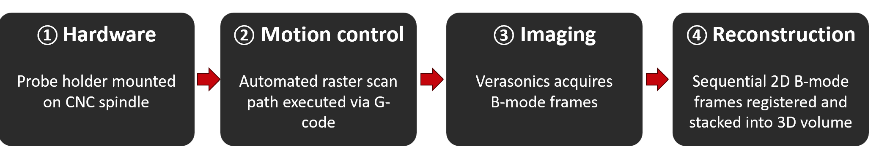Figure.1 Flowchart of motivation
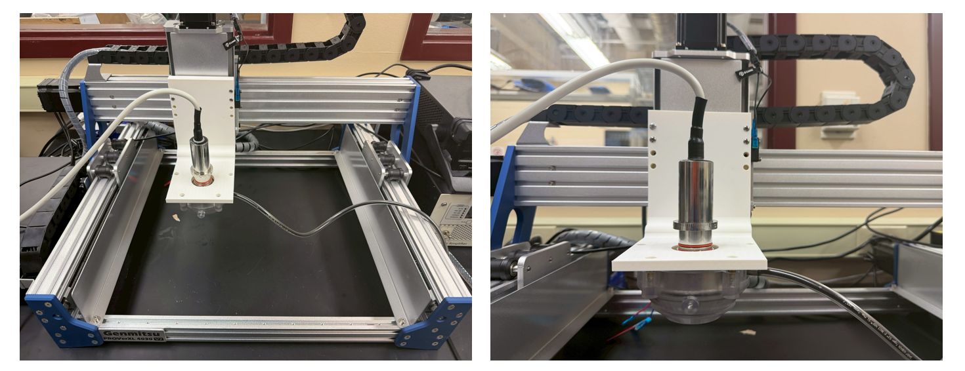
Figure 2. Proposed physical setup diagram
The goal of this project is to design and fabricate a low-cost 3D-printed probe holder. The system supports stable and repeatable ultrasound scanning over large areas.[5] It is integrated with a Verasonics ultrasound system for data acquisition.[6][7] In combination with 3D reconstruction techniques, the system enables frame-based three-dimensional volumetric reconstruction and visualization of internal structures. This approach reduces uncertainty, and it also improves reconstruction accuracy.[8][9] The proposed system provides a practical solution for repeatable, scalable, and accurate ultrasound imaging.[10] The flowchart of the proposed methodology is illustrated in Figure 1, while the proposed physical setup is shown in Figure 2.
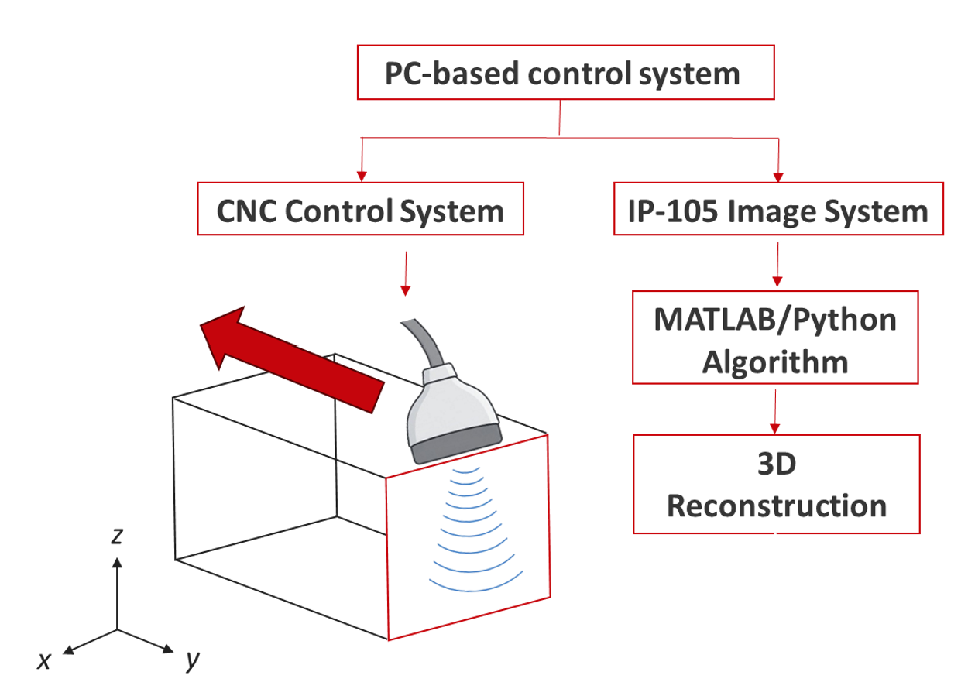
Figure. 3 System architecture diagram
This study is organized into several sections to systematically introduce the development of the proposed ultrasound scanning platform. First, the hardware design of the 3D-printed probe holder and the mechanical scanning system will be presented. This section focuses on the structural design, stability considerations, and scanning mechanism for large-area ultrasound imaging. Next, the integration of the Verasonics ultrasound system with the scanning platform will be introduced, including data acquisition, synchronization, and system control.
Finally, the 3D reconstruction methodology will be described, including frame-based volumetric reconstruction and image processing using MATLAB/Python algorithms. The overall workflow and system architecture are illustrated in the following sections in sequential order. The System Architecture Diagram is illustrated in Figure 1

Probe Holder Design

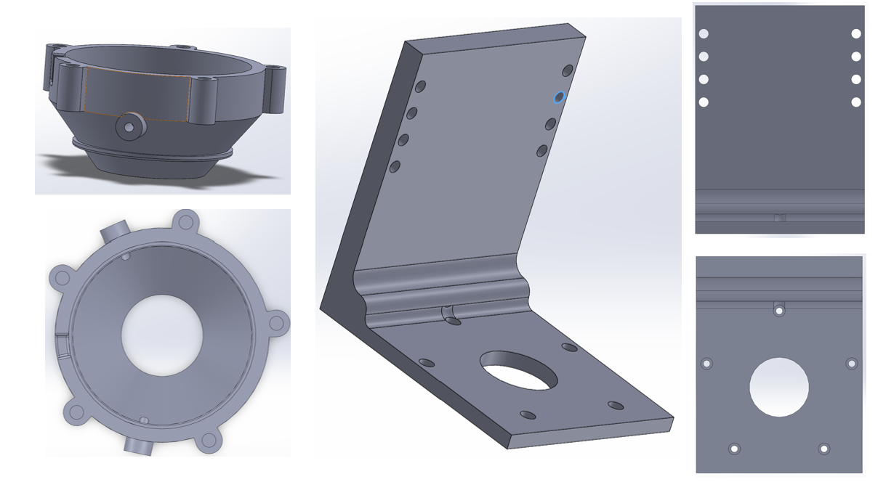
Figure. 4 CAD model of probe housing and holder

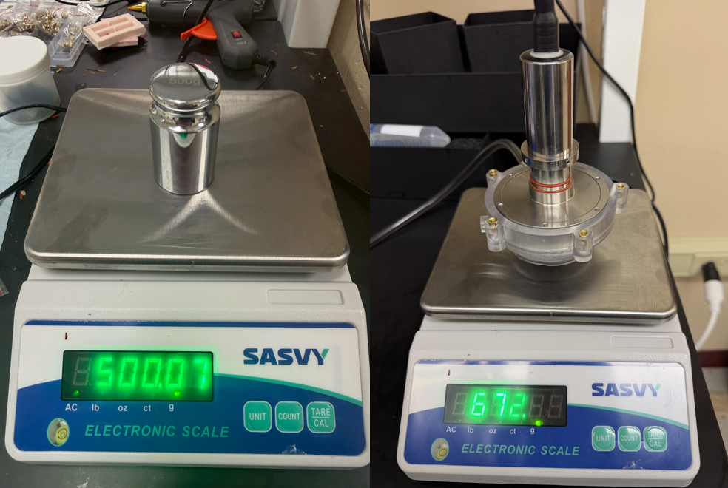
Figure. 5 Weight Measurement of the probe and its housing
The figure. 4 shows the previously developed probe housing designed by a former laboratory member. In this study, a customized holder was designed to connect the ultrasound probe, the housing structure, and the beam of the CNC control system, which is also shown in figure. 4. The holder provides mechanical support and maintains stable alignment during automated ultrasound scanning.
The figure. 5 shows the weight measurement process used to estimate the loading condition applied to the holder. To perform stress distribution analysis and evaluate whether the holder can safely support the combined weight of the probe and housing, the total mass must first be determined accurately. Calibration weights were used to verify the accuracy of the electronic scale, and the measurement results showed minimal deviation.
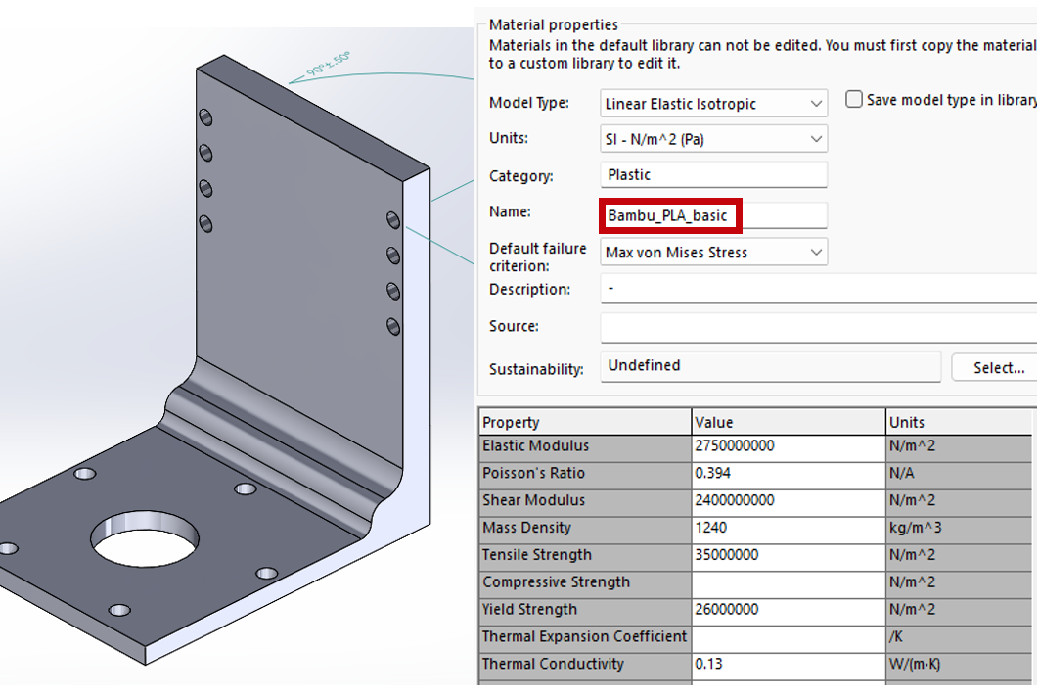
Figure. 6 Material properties setup of the holder
Figure 6 shows the material properties assigned to the holder model for structural simulation. The material was set as Bambu PLA Basic to match the actual 3D-printing condition. The yield strength of the material was defined as 26 MPa. This value was used as the failure criterion in the stress analysis to evaluate whether the holder could safely support the combined weight of the probe and housing during operation.

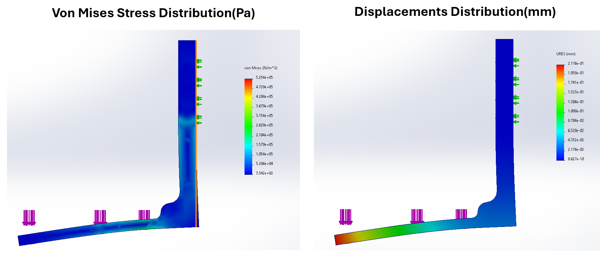
Figure. 7 Simulation Results: Von Mises Stress and displacements distribution
The simulation results show that under the loading condition of the 672 g probe and housing assembly, the maximum von Mises stress remained below the material yield strength of Bambu PLA Basic. Therefore, the holder is not expected to experience permanent deformation during operation. In addition, the overall displacement distribution was within an acceptable range, indicating that the holder provides sufficient structural stability for the ultrasound scanning system.
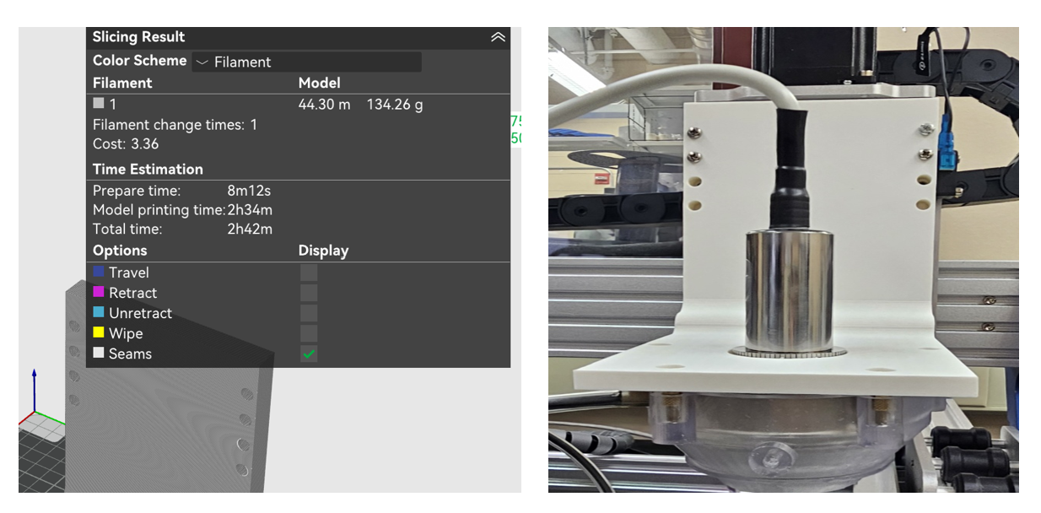
Figure. 8 Sliced results of the holder and actual 3D printing model of Holder
For the 3D-printing setup, the infill density was set to 15% using a grid sparse infill pattern to reduce material usage and printing time while maintaining sufficient structural support. The top and bottom surfaces were configured with three solid layers using the monotonic pattern to improve printing consistency. Other parameters were kept at their default settings without further optimization. The holder was fabricated using PLA Matte filament, and the total printing time was approximately 2 h 42 min, demonstrating that the design can be fabricated efficiently using a low-cost 3D-printing process.
After fabrication, the holder was assembled with the probe housing and mounted onto the CNC control system for preliminary mechanical evaluation. Experimental observations showed that the fabricated holder provided sufficient mechanical strength to safely support the combined weight of the probe and housing assembly during operation. No obvious bending deformation, excessive displacement, or structural instability was observed under the loading condition. In addition, the holder maintained stable alignment throughout the setup process, which is important for ensuring repeatable ultrasound scanning performance. These results indicate that even with a relatively low infill density, the proposed 3D-printed holder can still achieve adequate structural rigidity and practical applicability for large-area ultrasound imaging experiments.

CNC Control System Setup
Figure. 9 shows the control interface of the Universal G-code Sender (UGS) software used in this study. UGS was utilized to communicate with the CNC control system and execute predefined motion paths through G-code commands. The software provides real-time control and monitoring of the probe movement along different scanning axes.
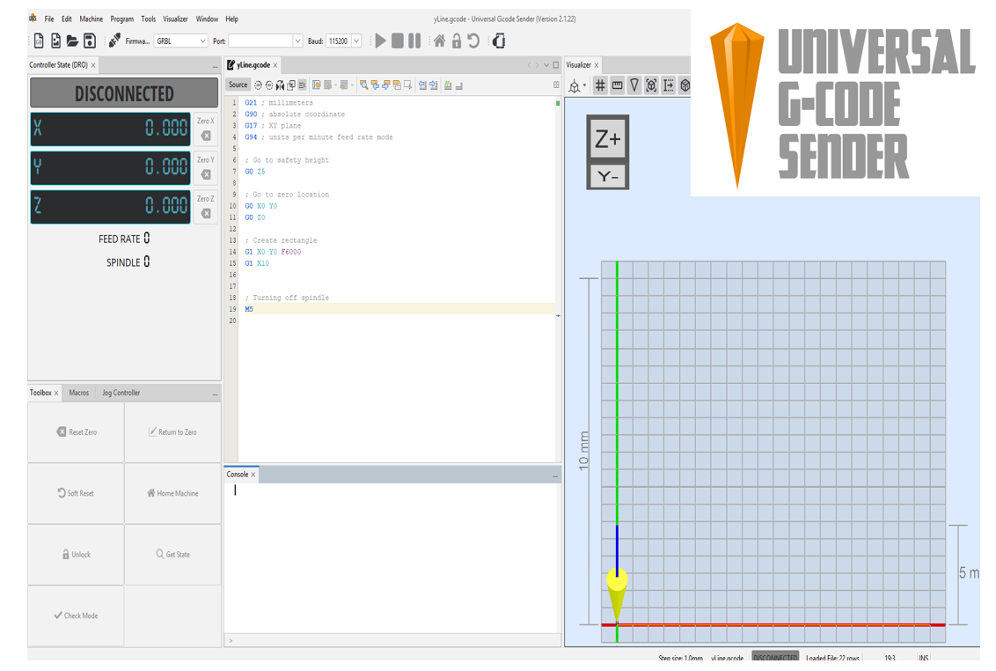
Figure. 9 Control interface of the Universal G-code Sender software used for CNC motion control and automated ultrasound scanning.
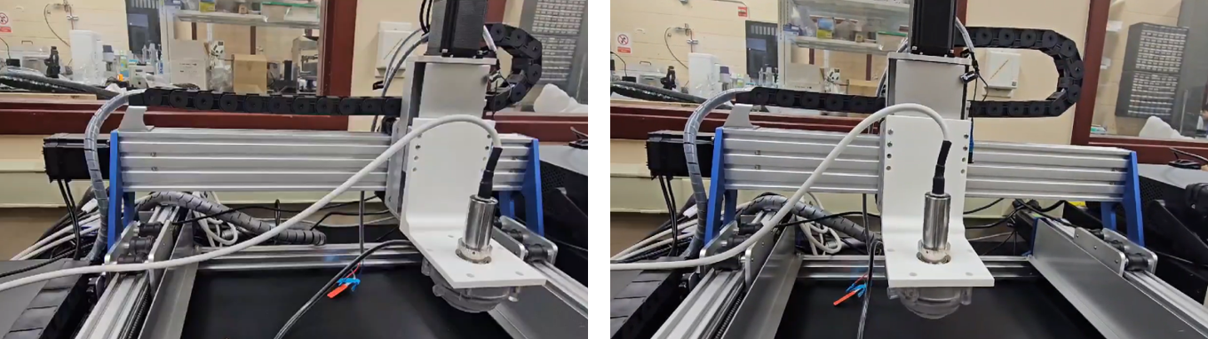
Figure. 10 CNC-based ultrasound scanning system with the 3D-printed probe holder
In this study, the scanning trajectory and movement speed were programmed using G-code to achieve stable and repeatable ultrasound scanning over the target area. The visualization interface also allows users to verify the scanning path before operation, reducing positioning errors during automated scanning. Through integration with the CNC platform, the system enables precise probe motion control for synchronized ultrasound data acquisition and subsequent 3D reconstruction.

IP-105 Automatic Saving System Setup
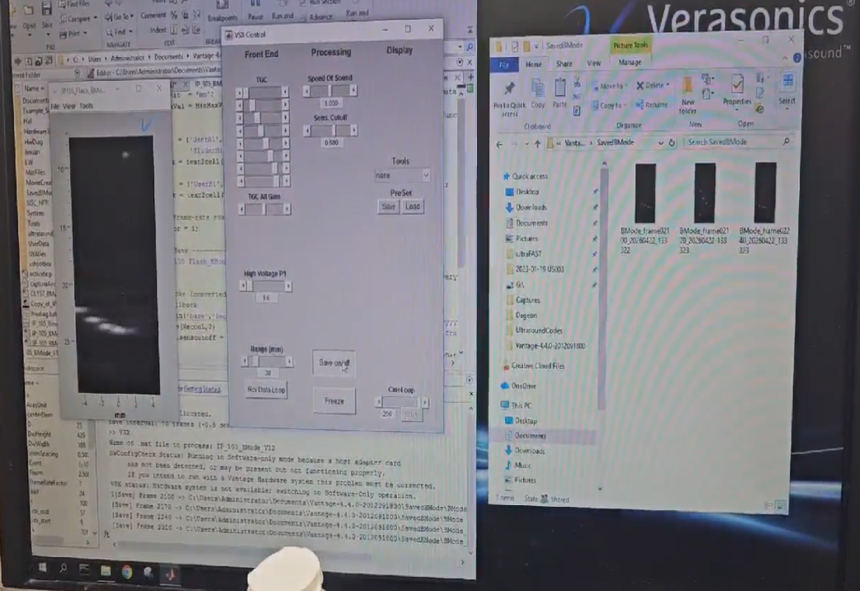
Figure. 11 Automated image-saving process of the IP-105 ultrasound imaging system during real-time data acquisition.
An automated image-saving pipeline was developed for the IP-105 ultrasound imaging system to improve the efficiency and stability of data acquisition during ultrasound scanning experiments. The system was designed to automatically capture and store ultrasound image data during operation, reducing the need for continuous manual interaction. Different saving modes were implemented, including frame-based and time-based acquisition intervals, allowing flexible adjustment depending on the scanning speed and experimental requirements.
The automated saving function is particularly important for large-area scanning and long-duration imaging experiments, where a large number of ultrasound frames must be recorded continuously for subsequent analysis and 3D reconstruction. By integrating the saving process directly into the imaging workflow, the system can maintain continuous data acquisition while minimizing interruptions during scanning. In addition, the automated pipeline reduces the possibility of human error, such as missing frames or incomplete data storage caused by manual operation.
The developed system was integrated with the Verasonics/IP-105 imaging platform and successfully demonstrated real-time automatic image saving during ultrasound imaging experiments. The recorded image sequence can later be used for image processing, spatial alignment, and volumetric reconstruction, providing a more reliable and efficient workflow for automated ultrasound imaging applications.

3D Image Reconstruction Method
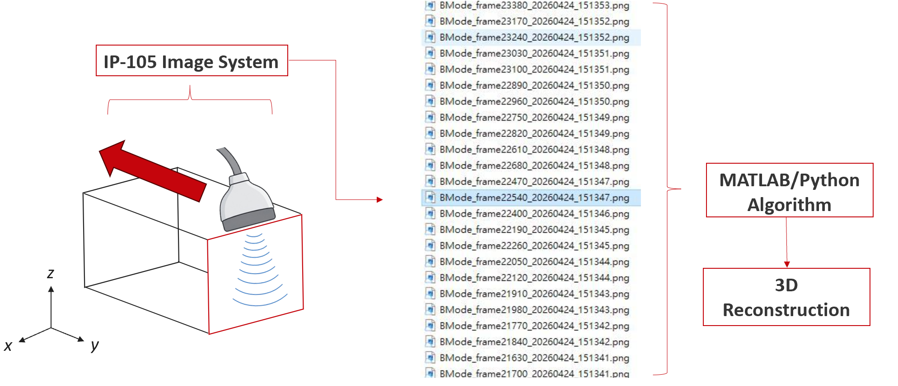
Figure. 12 Workflow of frame-based 3D ultrasound reconstruction using the IP-105 imaging system and MATLAB/Python algorithms
This study employed a frame-based 3D reconstruction method for volumetric ultrasound imaging. During automated scanning, the IP-105 ultrasound imaging system continuously acquired B-mode ultrasound images while the probe moved along the predefined scanning trajectory. The captured image frames were automatically saved in sequential order to preserve the spatial information associated with the probe position during scanning.
After data acquisition, the image sequence was processed using MATLAB/Python algorithms for volumetric reconstruction. The reconstruction process stacked the sequential 2D ultrasound frames according to the scanning direction and positional relationship to generate a three-dimensional representation of the scanned region. This workflow enables large-area ultrasound imaging with improved repeatability and reduced positioning uncertainty compared to manual freehand scanning. By integrating automated scanning, continuous image acquisition, and computational reconstruction, the proposed system provides a practical approach for repeatable and scalable 3D ultrasound imaging applications.
Figure. 13 shows the cross-sectional reconstruction result of the scanned sample. The left image presents the actual lattice structure sample, and the red line indicates the selected slicing position for cross-sectional analysis. The right image shows the corresponding XZ-plane cross-sectional view extracted from the reconstructed 3D volumetric data. Bright regions in the reconstructed image represent stronger ultrasound reflections associated with structural boundaries within the sample. The result demonstrates that the proposed system is capable of performing frame-based 3D reconstruction and extracting internal cross-sectional information from the volumetric ultrasound dataset.
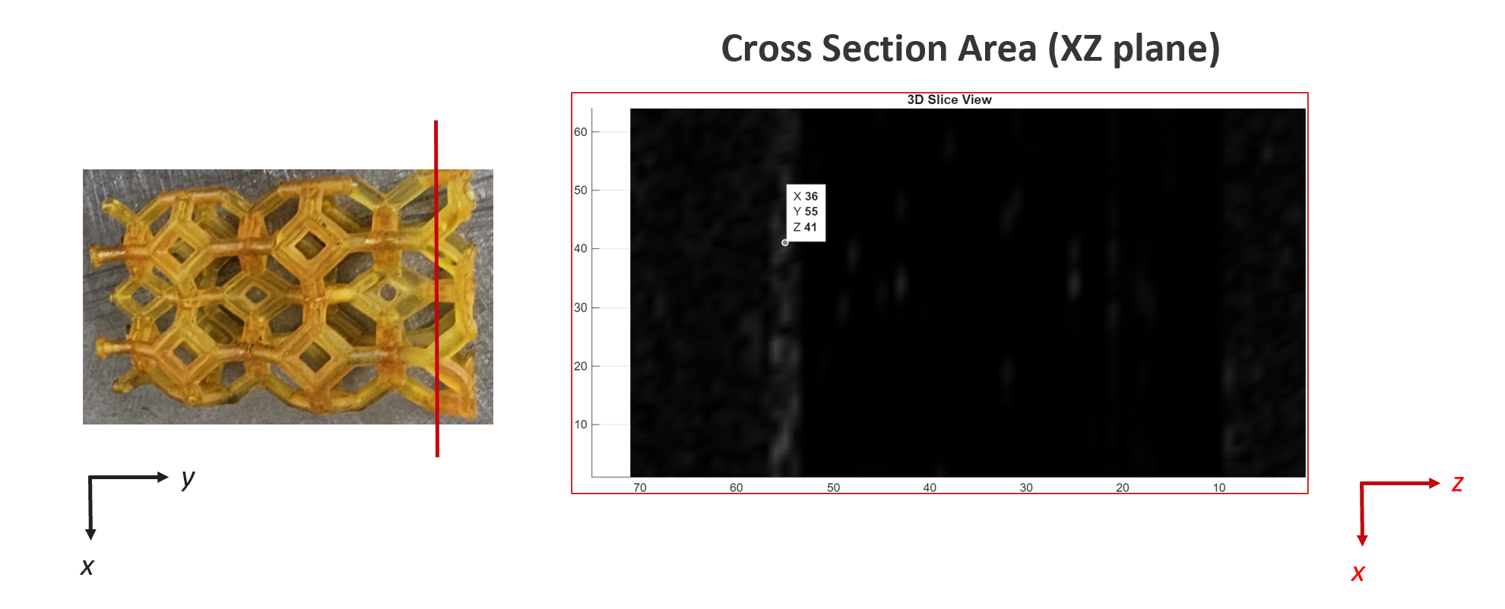
Figure. 13 XZ-plane cross-sectional view extracted from the reconstructed 3D ultrasound volumetric data.

3D Image Reconstruction Results
The reconstructed volumetric dataset allows cross-sectional visualization in multiple directions. In Figure. 14, the vertical plane represents the XZ-plane slice extracted from the reconstructed 3D ultrasound volume, while the horizontal plane corresponds to the XY-plane slice at a selected depth. The intersection between the two planes illustrates the spatial relationship between different cross-sectional views within the volumetric dataset.
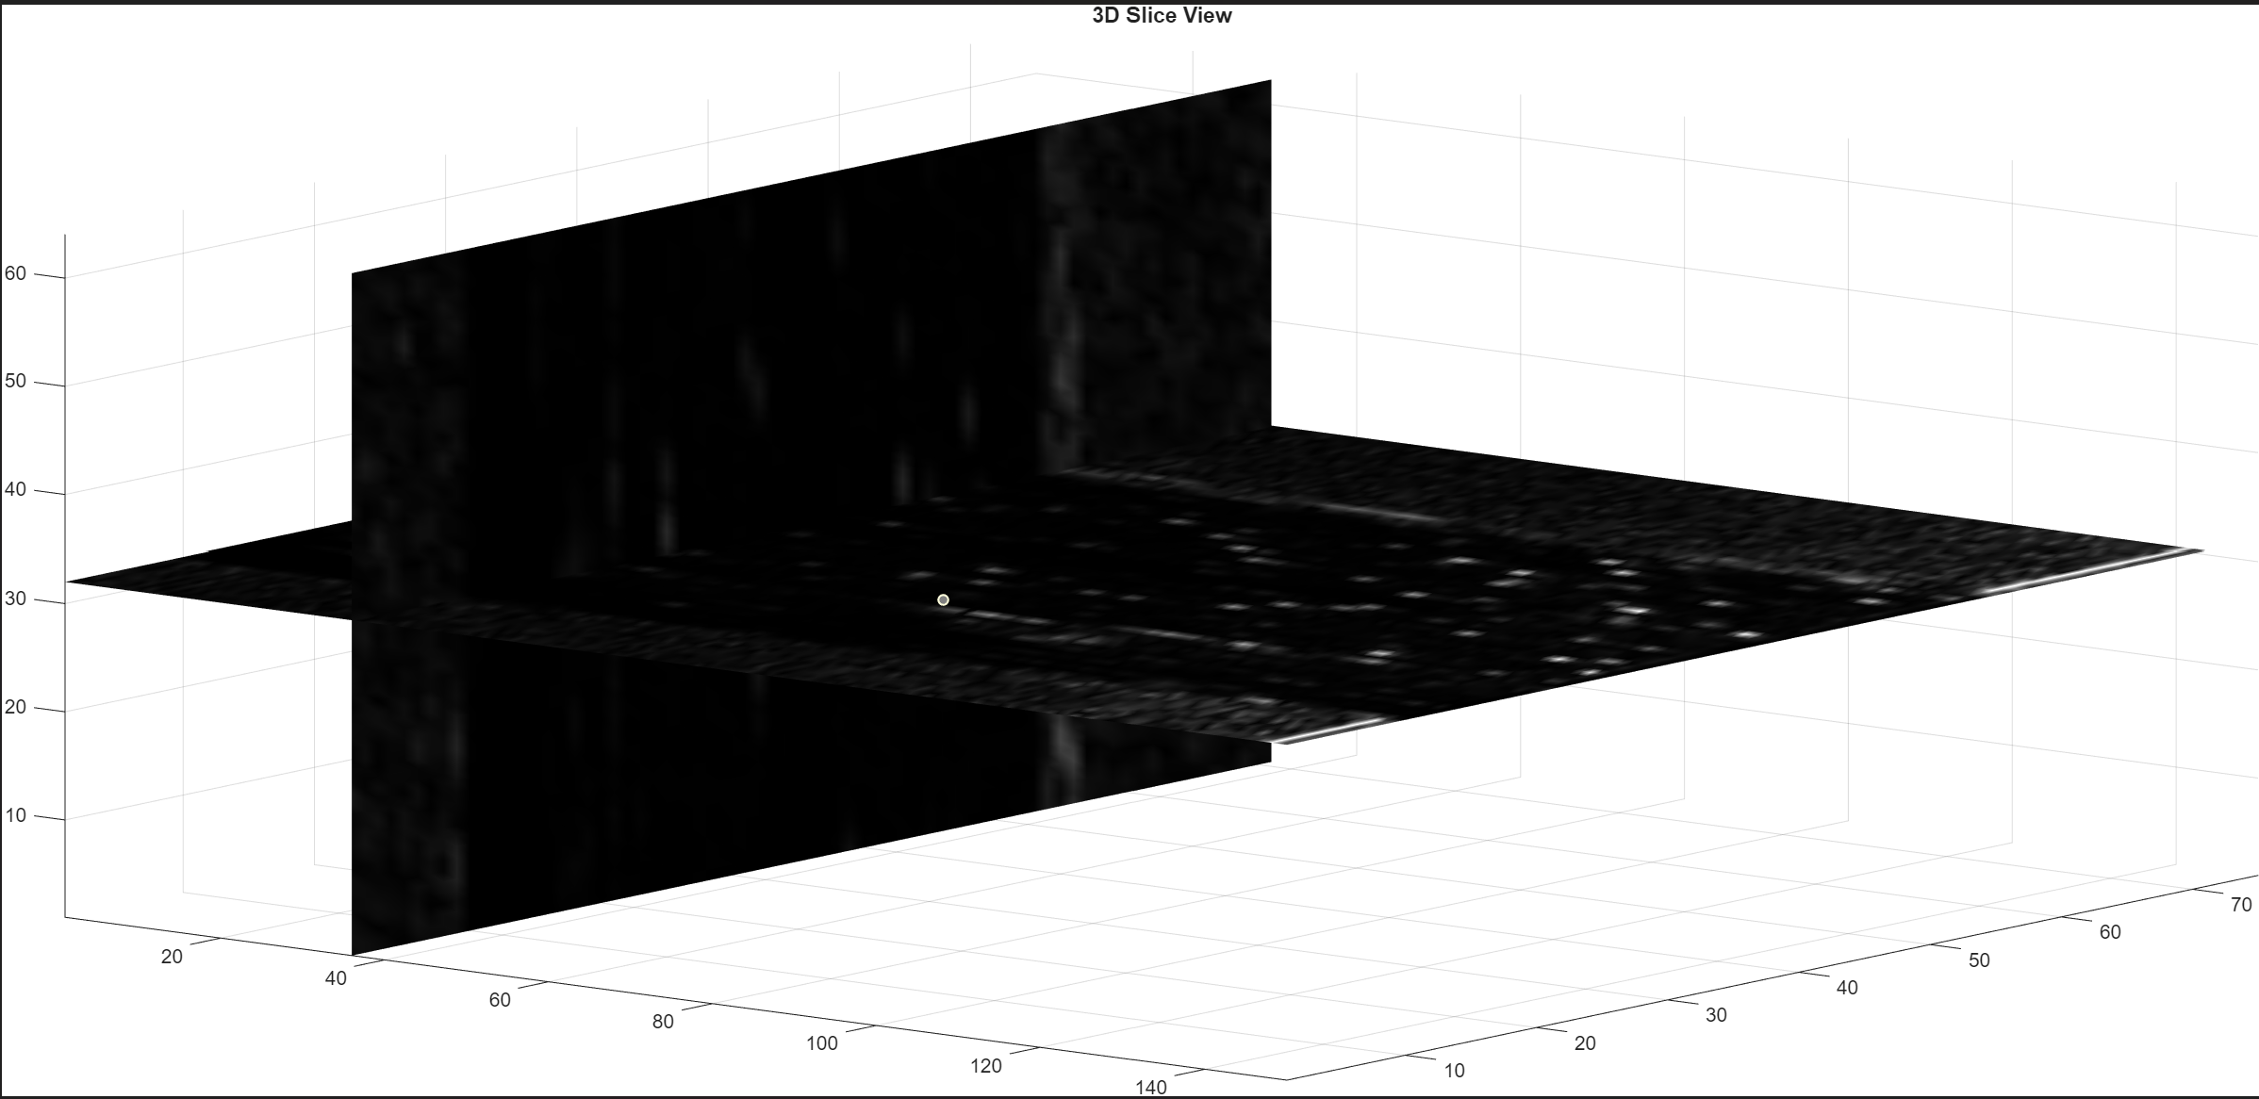
Figure. 14 Multi-plane slice visualization of the reconstructed 3D ultrasound volumetric dataset.

Figure. 15 shows the reconstructed XY-plane slice after reorientation for clearer visualization. The internal structural distribution and reconstructed pattern of the scanned sample can be observed more directly in the XY plane. These results demonstrate that the proposed system is capable of performing frame-based volumetric reconstruction and extracting multi-plane cross-sectional information from ultrasound image sequences.
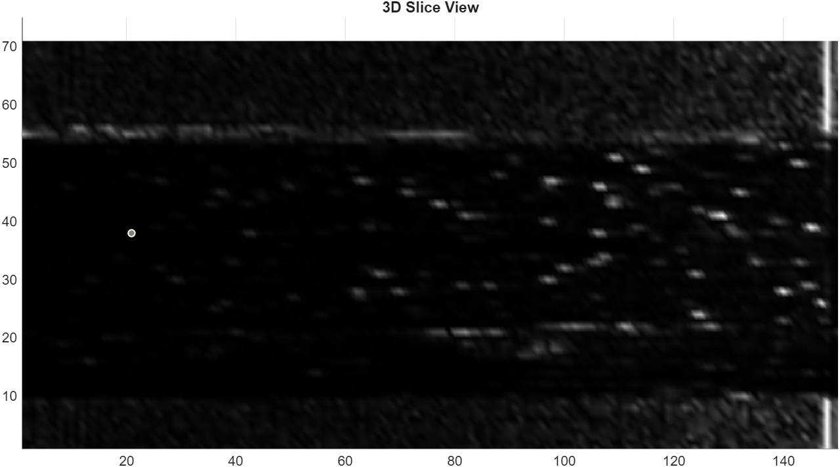
Figure 15. Reoriented XY-plane slice extracted from the reconstructed ultrasound volume
The reconstruction results indicate that the proposed frame-based ultrasound volumetric reconstruction method is still unstable when applied to complex geometries. As shown in Figure. 16, complicated lattice-like structures produce discontinuous reflections and scattered signals, resulting in fragmented and noisy reconstruction results. The accumulated positioning uncertainty and complex acoustic reflections make it difficult to preserve the original structural features accurately.
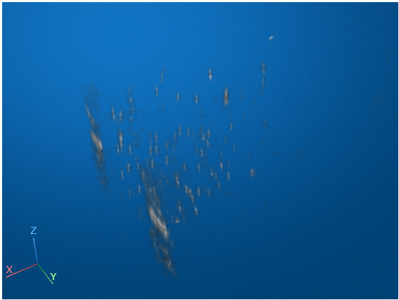
Figure. 16 Reconstruction result of a complex lattice structure showing fragmented and unstable volumetric reconstruction.
To further validate the feasibility of the proposed scanning and reconstruction workflow, a simple ring-shaped geometry was used as the reconstruction target. Compared with complex structures, the circular geometry provides clearer and more continuous boundary reflections, which improves the consistency of frame alignment during volumetric reconstruction.
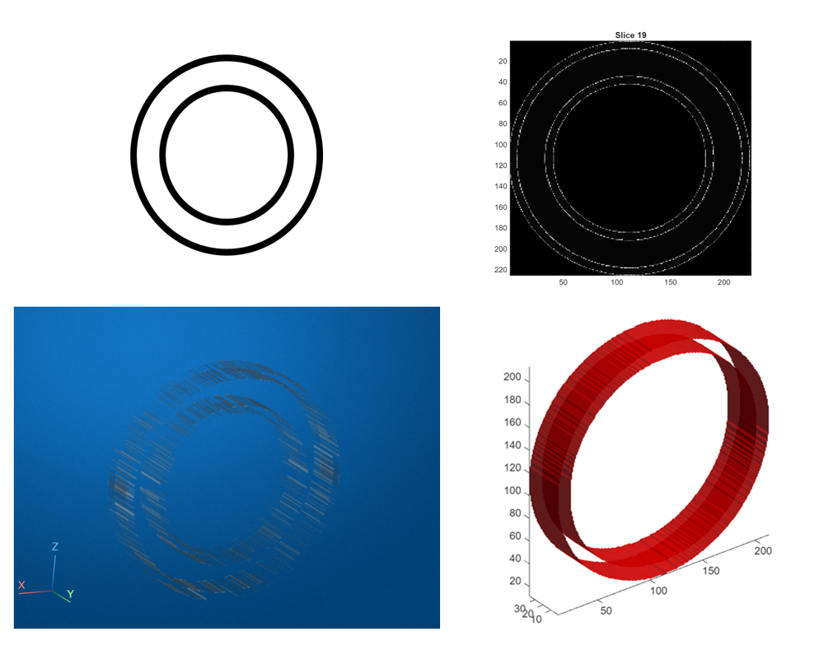
Figure 16. Reconstruction results of a simple ring-shaped geometry, including slice visualization and 3D volumetric rendering.
As shown in Figure 16, both the slice visualization and 3D rendering successfully reconstructed the overall ring-shaped structure from the sequential ultrasound image frames. The reconstructed results preserved the general circular boundary and demonstrated relatively stable spatial continuity during the reconstruction process. Compared with more complicated lattice geometries, the simple circular structure produced clearer reflection patterns and more consistent frame alignment, resulting in improved reconstruction quality.
These results demonstrate that the current system can reconstruct simple geometries with reasonable reliability using the proposed automated scanning and volumetric reconstruction workflow. However, reconstruction performance remains limited for complex internal structures due to irregular reflections, acoustic scattering, and accumulated positioning uncertainty. Further improvements in scanning precision and reconstruction algorithms are still required for stable reconstruction of more complicated geometries.

Conclusion
In this study, a low-cost CNC-based ultrasound scanning platform was successfully developed for automated large-area ultrasound imaging and frame-based 3D reconstruction. A customized 3D-printed probe holder was designed, fabricated, and integrated with the CNC motion system to improve probe stability and reduce operator-dependent variability during scanning. Structural simulation and experimental testing demonstrated that the holder provided sufficient mechanical strength and stability under the loading condition of the ultrasound probe and housing assembly.
The proposed system was integrated with the Verasonics/IP-105 ultrasound imaging platform, and an automated image-saving pipeline was developed to continuously record ultrasound image frames during scanning experiments. By combining automated scanning, continuous image acquisition, and MATLAB/Python-based reconstruction algorithms, the system successfully demonstrated volumetric reconstruction from sequential ultrasound image data.
Experimental results showed that the current reconstruction workflow can reliably reconstruct simple geometries, such as ring-shaped structures, while more complicated geometries still produce fragmented and unstable reconstruction results due to irregular reflections and accumulated positioning uncertainty. Nevertheless, the developed platform successfully verified the feasibility of automated ultrasound scanning and frame-based 3D volumetric reconstruction using a low-cost and scalable system architecture.

Future Perspectives
Future work will focus on improving the performance and stability of the proposed ultrasound scanning and reconstruction system. Scanning parameters such as ultrasound frequency, coupling medium, and scan speed can be further optimized to improve image quality and reconstruction accuracy.
In addition, the current workflow is not yet fully automated. Future development will aim to integrate CNC motion control, image acquisition, automatic data saving, and 3D reconstruction into a fully automated scan-to-reconstruction pipeline.
Further studies will also validate the reconstruction method using experimentally acquired scan data from different geometries and materials. Finally, the proposed system may be extended to other engineering materials, such as composites and metals, for broader non-destructive evaluation (NDE) applications.

Reference
- Prager, R. W., Gee, A. H., & Berman, L. (1999). Stradx: Real-time acquisition and visualization of freehand 3D ultrasound. Medical Image Analysis, 3(2), 129–140.
- Mahapatra, S., et al. (2021). Design of an ultrasound probe holder to minimize motion artifact during sonography. Proceedings of the ASME Design of Medical Devices Conference.
- Wang, J., et al. (2019). 3D-printing based transducer holder for robotic assisted ultrasound-guided HIFU therapy. Procedia Manufacturing, 36, 398–404.
- Chen, W.-R., et al. (2023). ALPHUS: Adjustable laboratory probe holder for ultrasound. SSRN Electronic Journal.
- Kratkiewicz, K., et al. (2020). Technical considerations when using Verasonics research ultrasound platform for developing a photoacoustic imaging system. arXiv preprint arXiv:2008.06086.
- Verasonics, Inc. (2022). Vantage research ultrasound systems. IEEE International Ultrasonics Symposium (IUS) Industry Profile.
- Verasonics, Inc. (2025). Company profile: Verasonics. Focused Ultrasound Foundation.Prager, R. W., Gee, A. H., & Berman, L. (1999). Stradx: Real-time acquisition and visualization of freehand 3D ultrasound. Medical Image Analysis, 3(2), 129–140.
- Solberg, O. V., Lindseth, F., Torp, H., Blake, R. E., & Nagy, D. (2007). Freehand 3D ultrasound reconstruction algorithms—A review. Ultrasound in Medicine & Biology, 33(7), 991–1009.
- Çiçek, Ö., Abdulkadir, A., Lienkamp, S. S., Brox, T., & Ronneberger, O. (2016). 3D U-Net: Learning dense volumetric segmentation from sparse annotation. In Medical Image Computing and Computer-Assisted Intervention (MICCAI).
- Milletari, F., Navab, N., & Ahmadi, S. A. (2016). V-Net: Fully convolutional neural networks for volumetric medical image segmentation. In International Conference on 3D Vision (3DV).

