Project Overview
Our overall project goal is to make a mini RC car that is fully 3d printed for the frame and chassis. The goal is to make the car as small as electronically feasible with off the shelf parts while maintaining cost. The group will also have to make multiple cars so repeatability of manufacturing will be important. The goal of this update was to get a working design created. The design of the Cad model was carried out in fusion 360 and solidworks. Off the shelf components were utilized in order to simplify the electrical components.

Cad Overview
In our small remote control car, steering is achieved through a servo motor that precisely controls the angle of the front wheels. The servo is linked to the car’s wheels making a simple steering mechanism, translating its rotational movement into the lateral motion that is needed to turn the wheels. When the user operates the remote control it will send a signal to the car’s receiver, dictating the servo’s position and consequently adjusting the front wheels’ alignment. From here as the wheels turn left and right the car turns with them accordingly.

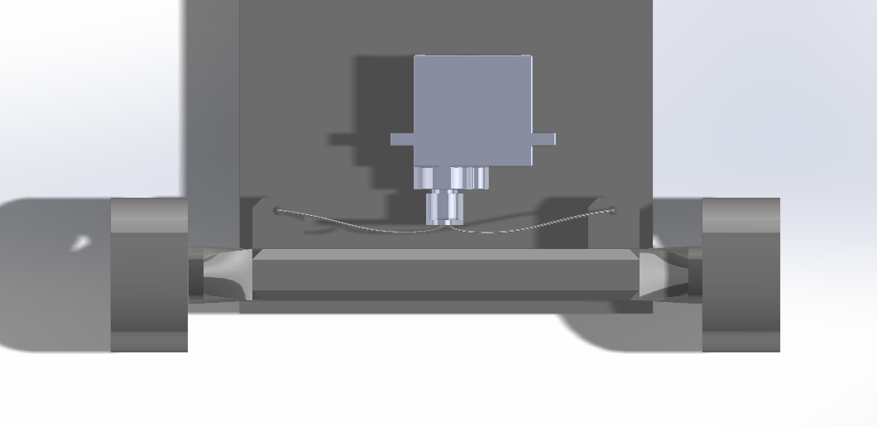
Figure 1. Steering Assembly

The process of accelerating is between the radio receiver (in red), the controller, and the car’s motors. When the user inputs a command to speed up through the controller, this signal is transmitted to the car’s onboard receiver. This instruction is then relayed to the car’s raspberry pi which supplies power to the drive motors. As the power to the motors increases, they spin faster. These motors are connected to the car’s wheels through a small system of drive pulleys. The drive pulleys allow for the form factor of the car to be slimmer while also increasing the speed of the car. This is due to the belt on the motor being attached to a larger pulley than the axle.
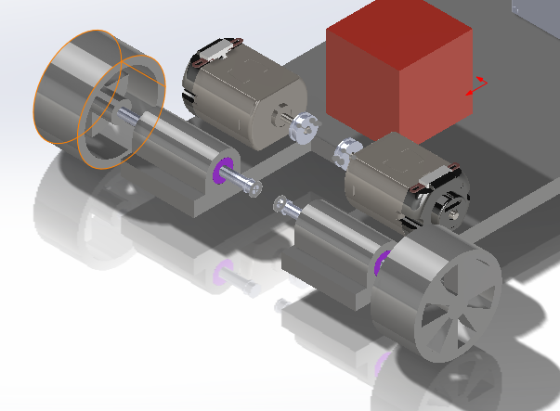
Figure 2. Rear Propulsion

The car’s initial design was designed in Blender and we plan on exporting this and printing the shell of the design so that the electronics and frame all fit inside of it.

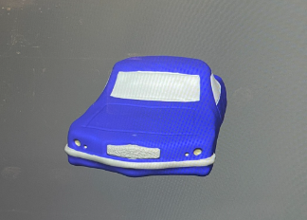
Figure 3. Body Design

When printing the parts we initially printed from the ground up since we are waiting on parts. Because of this when we started looking at the material the wheels were made of and how it felt against various surfaces we decided to change our material and make them out of TPU for future iterations. This way we get increased traction on hard wood floors along with other more slippery surfaces.
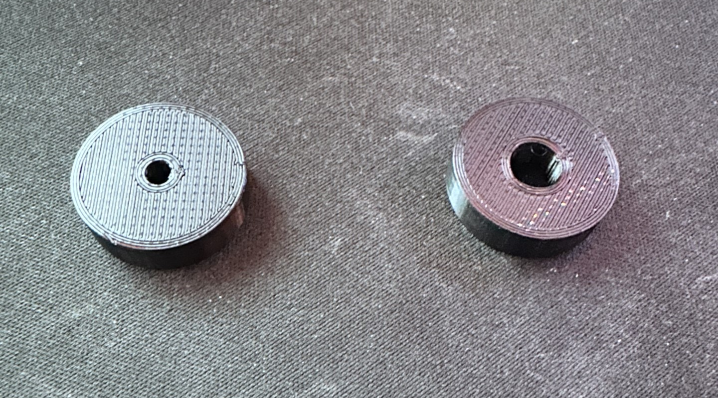
Figure 4. Wheel Design
Electrical Schematic
For the electrical components of the RC car we will be utilizing off the shelf parts. In reality the car won’t be a real “RC” car since it doesn’t use radio control, it will instead use bluetooth for the sake of on hand hardware. This will be done by utilizing a raspberry pi which is effectively a shrunken computer. The raspberry pi will then control a L298N motor driver since that is one of the cheapest motor drivers one can get. The L298N will carry the high amperage load to the motors without passing it through the raspberry pi. A PWM signal for the servo can be sent directly from the raspberry pi and the power for the servo will come from a 5v rail created with a buck converter from the 12v battery source. A schematic of the electrical system is outlined in Figure 5.
To control the car a bluetooth keyboard or controller can be connected to the raspberry pi. A python script will be running on the raspberry pi that tracks keyboard inputs and then passes that as commands to the motor driver and servo. The python script can be set to run automatically on boot up so there will be no need to access the desktop of the raspberry pi to start the program.

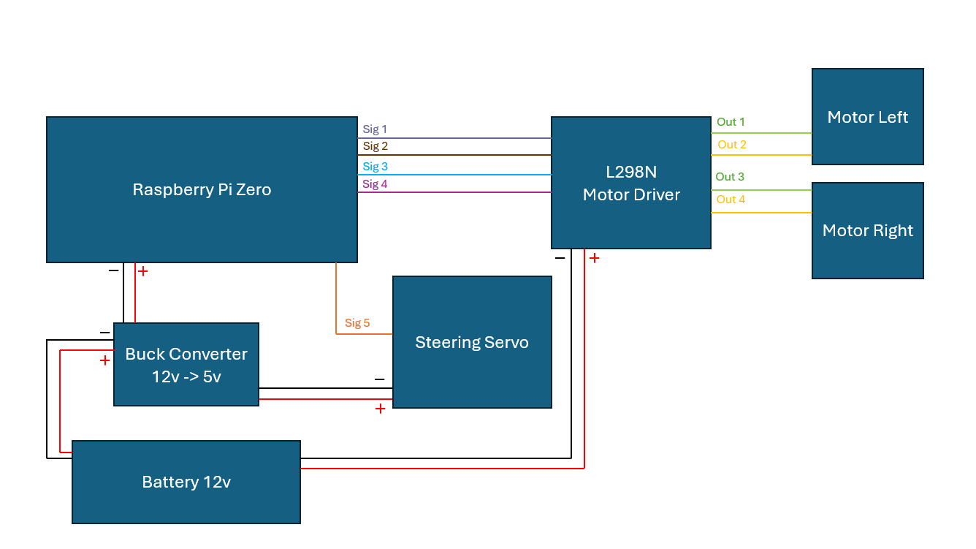
Figure 5. Electrical Schematic

As seen in Figure 5 the electrical schematic is nothing too complex. The raspberry Pi has an adequate amount of digital IO pins to drive everything. The L298N motor drivers sometimes overheat so we will have to ensure adequate cooling in this area. A 12v battery is used so that the motor can reach sufficient rpm. The 12v battery will have to be stepped down so that the servo and pi zero do not fry.

Future Work
With the current status of the model our next steps will be to print the car. The current plan is to either use the Bambu Lab X1’s we have available to us or a Prusa MK3S. The car will be printed out of PETG due to its better environmental resistance and strength. Our team has budgeted time to iterate the vehicle as needed to ensure adequate performance. We plan on testing the vehicle on different surfaces such as hardwood and carpet to ensure that it can drive properly. The program for the raspberry pi control will need to be created but there are well documented sources out there that are similar but in the field of robotics. An initial body of the car has been designed but there will be improvements and different variants created.

